**Digital Phase Locked Loop (PLL): DSP Implementation**

DSP Lab, Spring 2013

4/23/2013

Jacobs University Bremen

Joshan Chaudhary, Grishma Raj Pandeya

**1. A printout of your final C implantation of the PLL. You can just print out the pll_init() and pll() functions (you do not have to print all of the surrounding dap_ap.c code!).**

pll_state_def *pll_init(float f0, float T, float K, float damp, float mult)

{

pll_state_def *s;

float wn, tau1, tau2;

/* Allocate a new pll_state_def structure. Holds state and parameters. */

if ((s = (pll_state_def *)MEM_calloc(PLL_SEG_ID, sizeof(pll_state_def), PLL_BUFFER_ALIGN)) == NULL)

{

SYS_error("Unable to create state structure for PLL.", SYS_EUSER, 0);

return(0);

}

/* Copy input parameters */

s->f0 = f0;

s->damp_fact = damp;

s->K = K;

s->mult = mult;

/* Compute the filter coefficients */

/* Add your code here !!! */

wn = 2.0*M_PI/100.0;

tau1 = K/(wn*wn);

tau2 = 2.0*damp/wn - 1.0/K;

s->a1 = -(T - 2.0*tau1)/(T + 2.0*tau1);

s->b0 = (T + 2.0*tau2)/(T + 2.0*tau1);

s->b1 = (T - 2.0*tau2)/(T + 2.0*tau1);

/* Set state variables (initially all 0) */

s->z_nm1 = 0;

s->v_nm1 = 0;

s->x_nm1 = 0;

s->y_nm1 = 0;

s->accum = 0;

s->accum2 = 0;

/* Set initial block amplitude (cannot be 0!) */

s->Ap = 1.0;

return(s);

}

/*---------------------------------------------------------------------------

* pll

* PLL process function.

*--------------------------------------------------------------------------*/

void pll(pll_state_def *s, const float x_in[], float y_out[])

{

int n;

float A;

float x_n;

float z_n;

float v_n;

float y_n;

float y_n2;

float daccum;

/* Add other temporary variables as needed. */

/* Do not put any arrays as local variables! */

/*

* If signal level is below some threshold, make Ap large, which has the

* effect of just doing holdover mode.

*/

if (s->Ap < 1.0E-3)

{

s->Ap = 100.;

}

A = 0.0; /* Variable for computing amplitude */

for (n=0; n<BUFFER_SAMPLES; n++)

{

/* Input sample (input reference) */

/* Take the sign of the input signal. */

x_n = x_in[n];

/* Estimate amplitude from summed |x| */

A = A + fabs(x_n);

/* Add your code here to do PLL operation !!! */

/* Code should generate y_n from x_n. */

z_n = s->x_nm1/s->Ap * s->y_nm1;

v_n = s->a1*s->v_nm1 + s->b0*z_n + s->b1*s->z_nm1;

/* Update the accumulator */

daccum = s->f0 - s->K/(2.0*M_PI)*v_n;

s->accum = s->accum + daccum ;

s->accum = s->accum - floor(s->accum);

y_n = sin_table[(int)(((float)SIN_TABLE_SIZE * s->accum))];

/* Put output sample */

if (s->mult == 2.0) {

s->accum2 = s->accum2 + daccum * s->mult;

s->accum2 = s->accum2 - floor(s->accum2);

y_n2 = sin_table[(int)(((float)SIN_TABLE_SIZE * s->accum2))];

y_out[n] = y_n2*0.2;

}

else if (s->mult == 0.5) {

s->accum2 = s->accum2 + daccum;

s->accum2 = s->accum2 - 2.0*floor(s->accum2/2.0);

y_n2 = sin_table[(int)(((float)SIN_TABLE_SIZE* 0.5 * s->accum2))];

y_out[n] = y_n2*0.2;

}

else {

y_out[n] = y_n*0.2;

}

//y_out[n] = y_n;

/* Shift current variables to previous values. */

s->z_nm1 = z_n;

s->v_nm1 = v_n;

s->x_nm1 = x_n;

s->y_nm1 = y_n;

}

/* Get amplitude estimate for next block (compute from A) */

s->Ap = A/(BUFFER_SAMPLES)/(2/M_PI);

}

3. A screen shot (like from the Scope program) showing that the PLL is tracking your input signal.

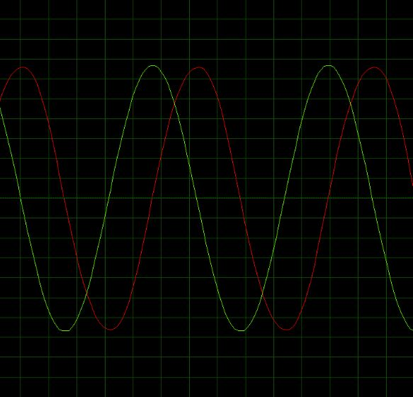

Fig: tracking at 800 Hz

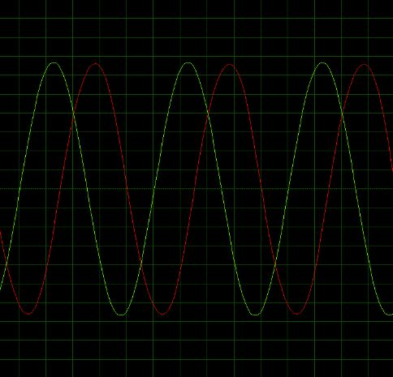

Fig: tracking at 1000 Hz

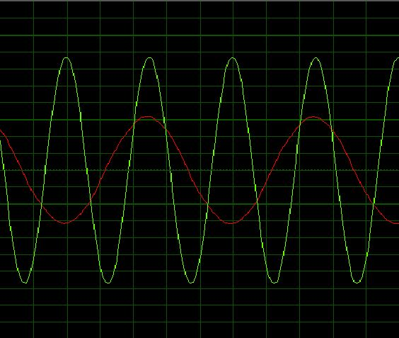

Fig: tracking for at half the input freq

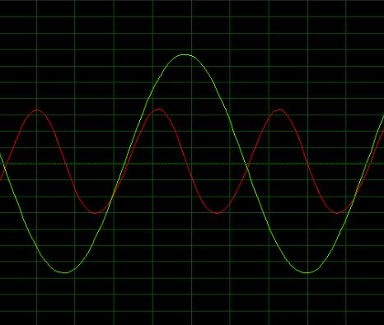

Fig: tracking at double the input frequency.